Lab # 10
JUnit Testing
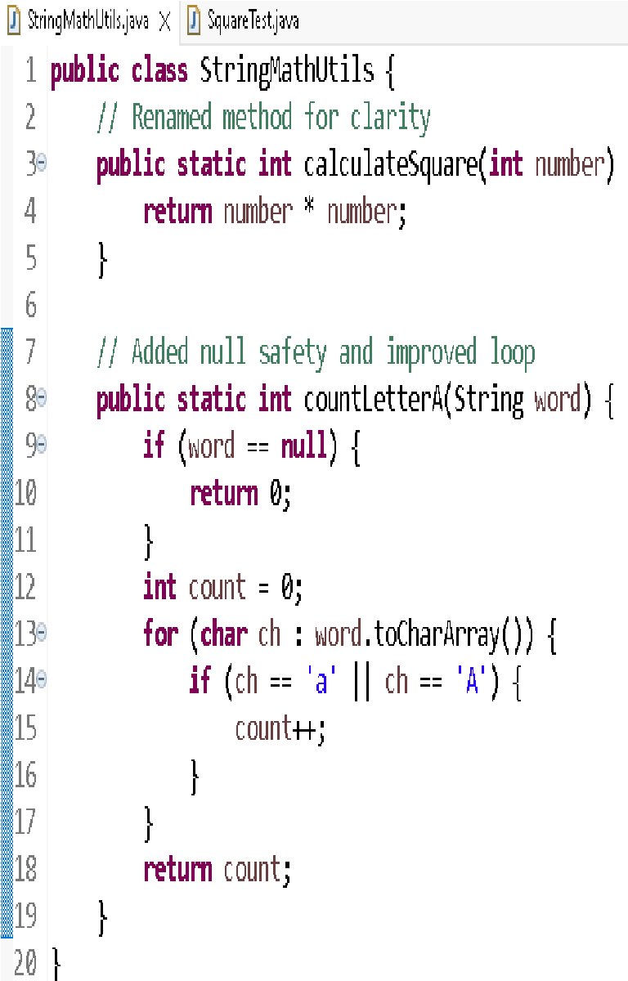
Original Code:- Refactored Code:-

public class JUnitTesting {
public int square (int x) {

return x*x;
}
public int countA(String word)
{
int count = 0; for (int i=0; i
<word.length();i++)
{

if(word.charAt(i)=='a' || word.charAt(i)=='A')
{count++;
}
}
return count;
}}

Original Unit Test:- Updated Unit Test:-
 | 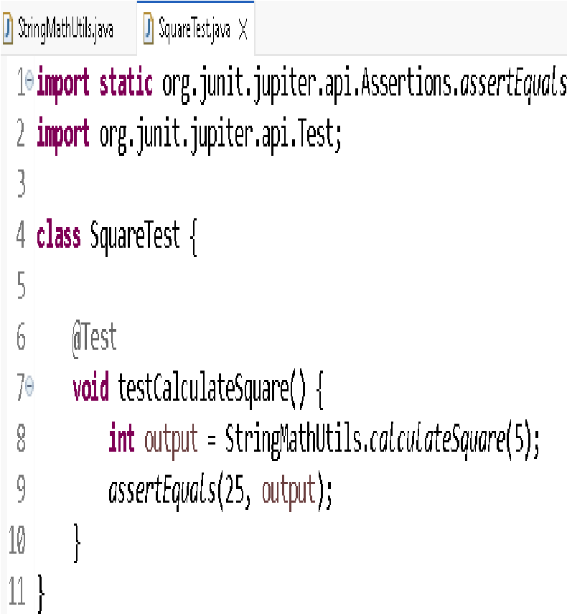
  class squareTest {
  @Test
  void test() {
  JUnitTesting obj=new
  JUnitTesting();
  int output=obj.square(5); assertEquals(25, output)
  }}

Output:-
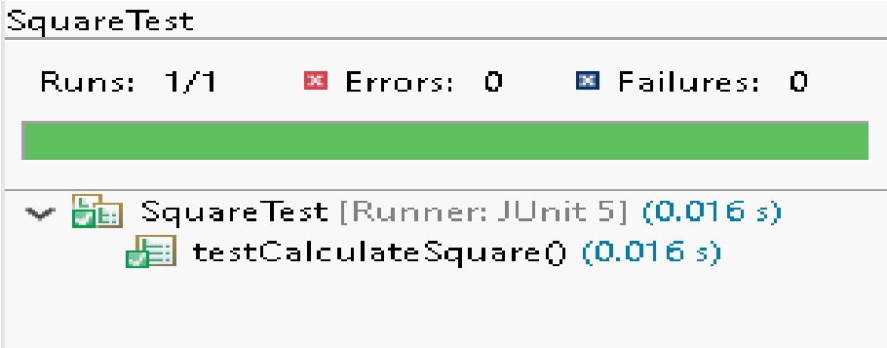

Lab Tasks:
-

- Add another test case for countA function (which is given in code).
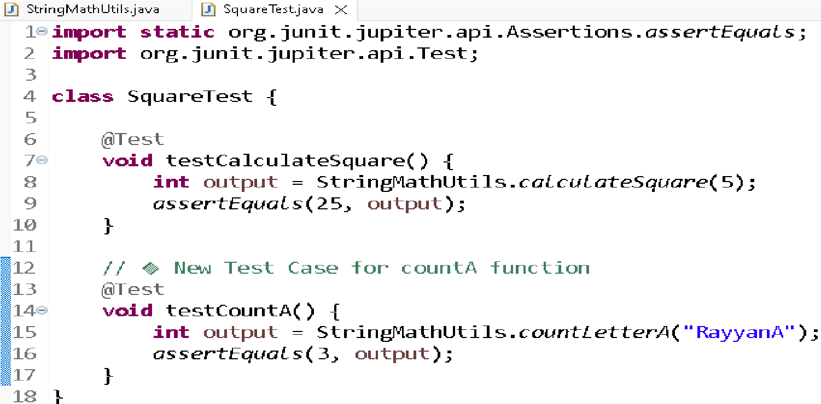
Unit Test:
-

Output:
-

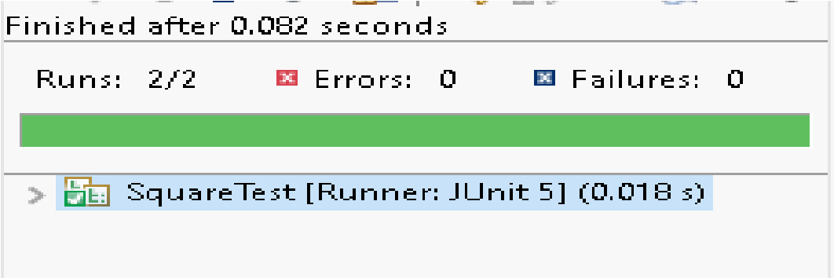

- Make new project, make a class. Add 2 methods in it. One method will find the max integer present in the input integer array. The other method will find the min integer. Now create test cases for both these methods and test your code. Follow all the steps as mentioned above in the manual.

Code:-
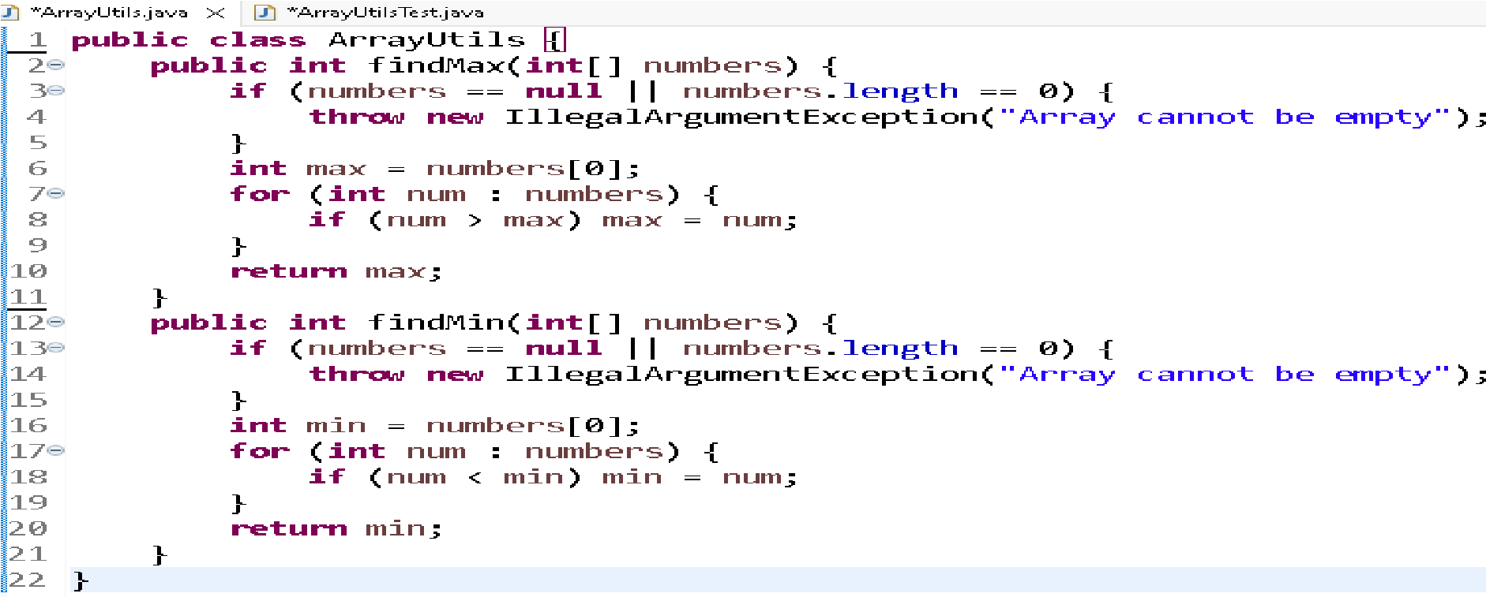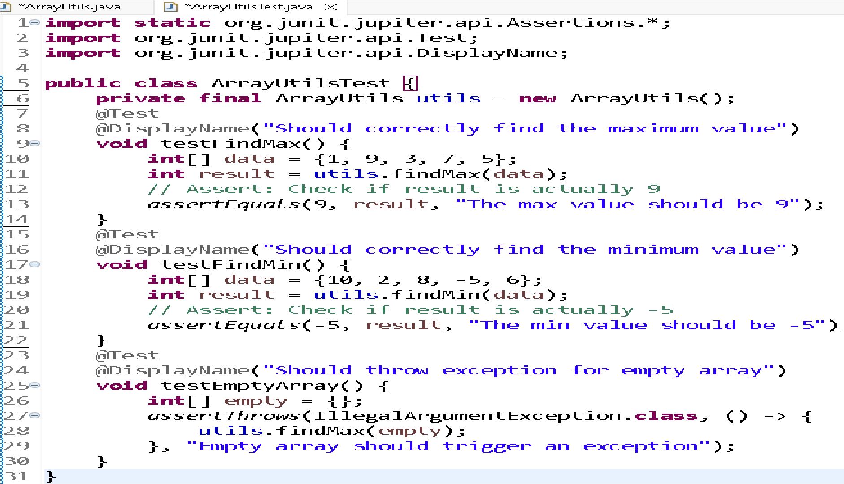

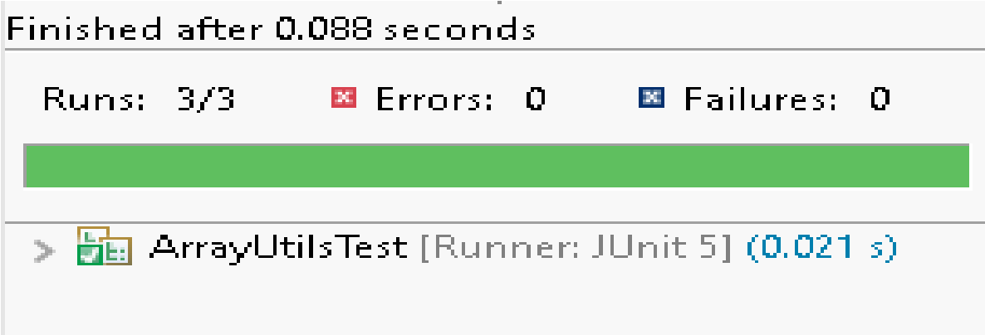
Output:
-

